Name: Ritika Mohan
Prn: 23070521183
Semester: 5th C (C1)
Aim: JavaScript Setup and Developer Tools:
Demonstrate use of inline, internal, and external JavaScript. Use console methods such as console.log(), console.error(), console.table(), and console.trace(). Create a simple webpage that logs user environment info and shows a welcome message.
Output:
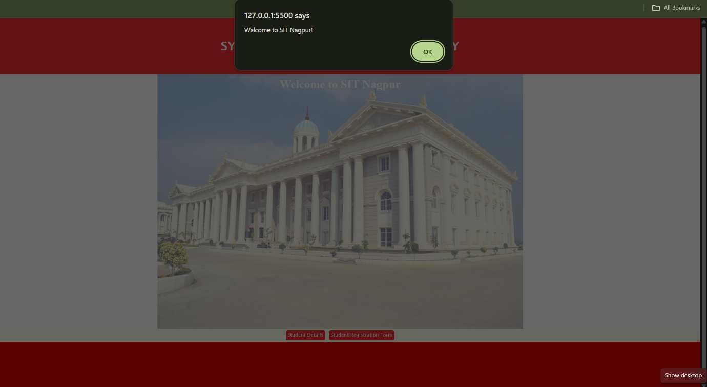
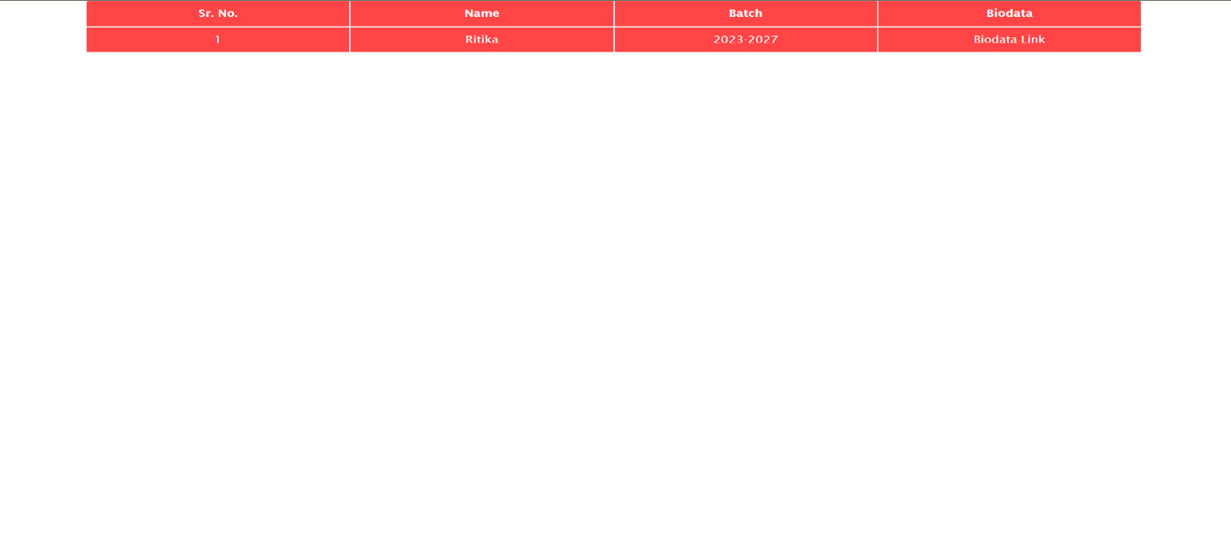
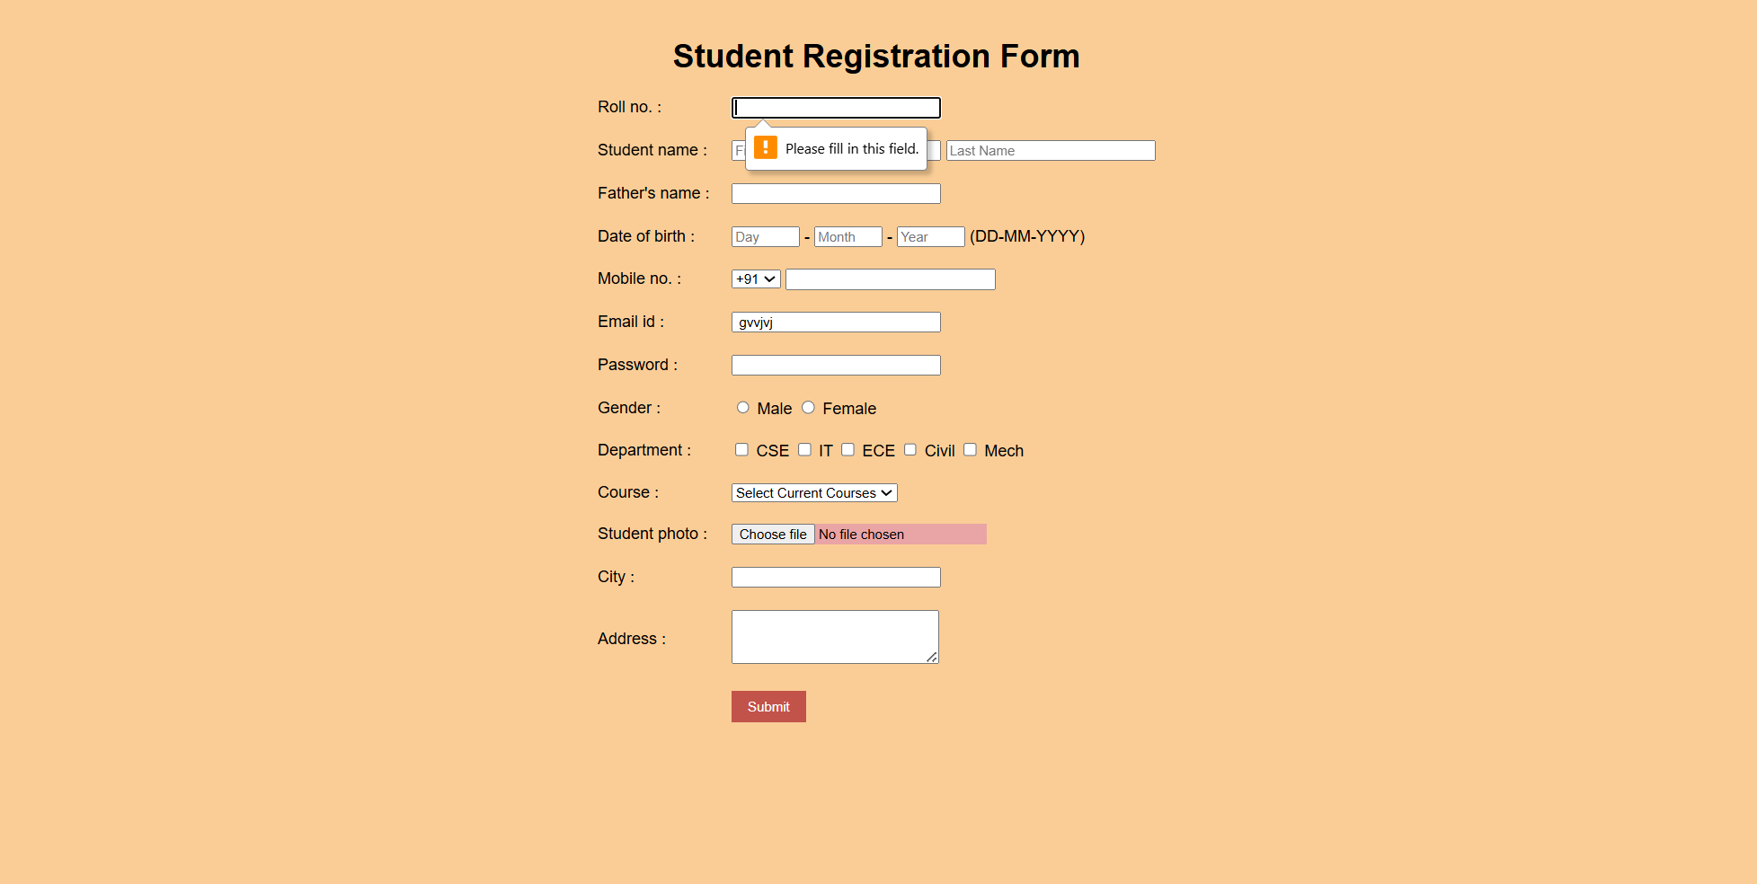
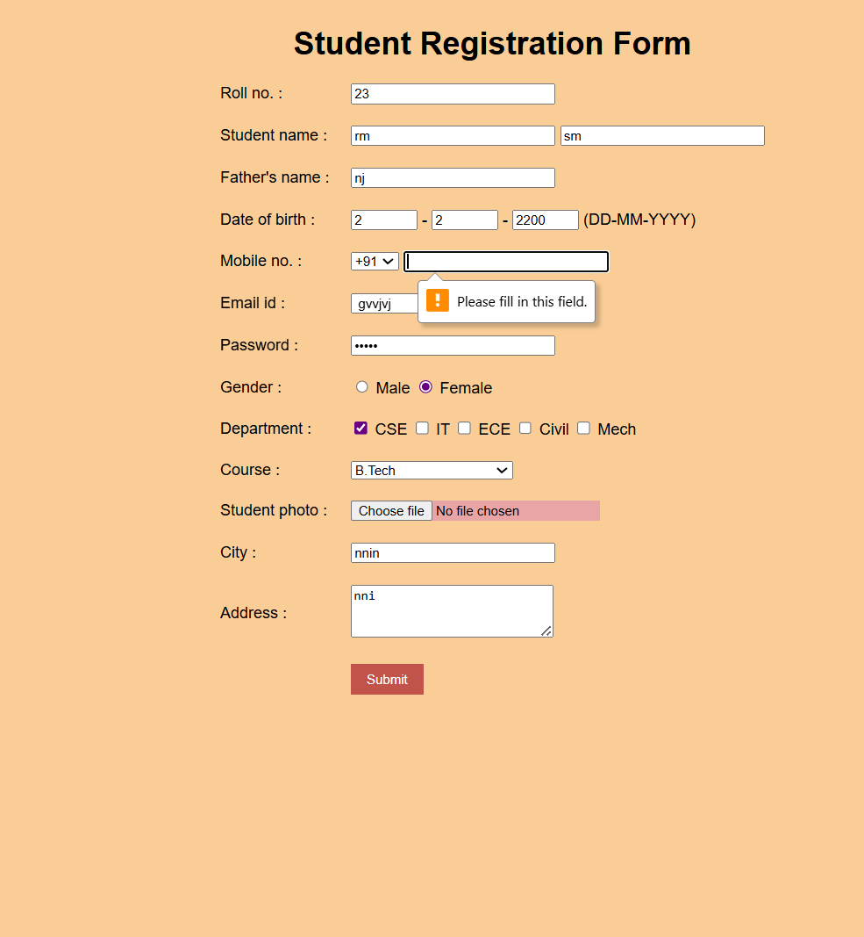

Theory:
JavaScript Integration in HTML
JavaScript can be added to a webpage in three ways:
- Inline JavaScript
  - Code is written directly inside an HTML tag using the onclick, onmouseover, etc. attributes.
  - Example:
<button onclick="alert('Hello!')">Click Me</button>
- Internal JavaScript
  - Code is written inside <script> tags within the same HTML file (usually inside <head> or <body>).
  - Example:
<script>
console.log("This is internal JS");
</script>
- External JavaScript
  - Code is written in a separate .js file and linked using the <script src="file.js"></script> tag.
  - Promotes code reusability and clean separation of structure (HTML), styling (CSS), and logic (JS).
Console Methods
The browser console is used for debugging. Common methods include:
- console.log(message) → Outputs general information
- console.log("Page Loaded Successfully");
- console.error(message) → Displays error messages in red
- console.error("Something went wrong!");
- console.table(object/array) → Displays data in a tabular format
- console.table(["Chrome", "Firefox", "Edge"]);
- console.trace() → Shows the stack trace of function calls (helps in debugging call flow)
- function test() { console.trace(); }
- test();

Conclusion: Created a webpage for college department and link the student information page with it and write a Java Script Program to Display “Welcome to SIT Nagpur” in an alert Box.

